Install MySQL for the database.

I've shared the link below:  
link -: https://dev.mysql.com/downloads/installer/

After installation I have attached the screenshot for installation and how to set path variables

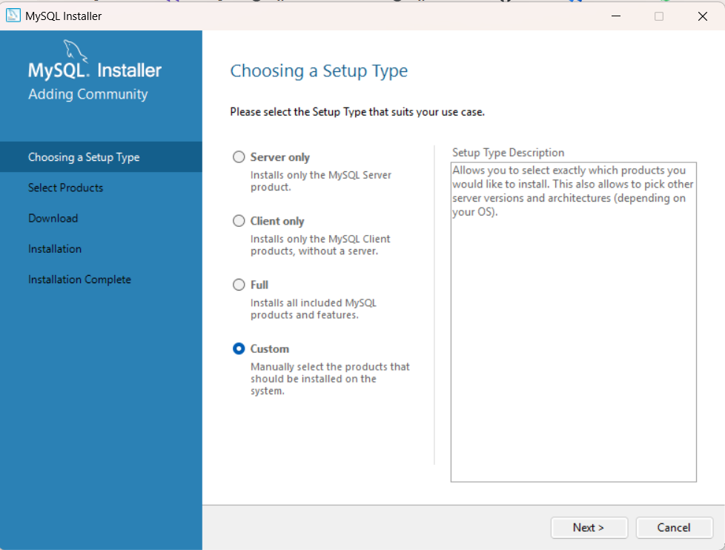

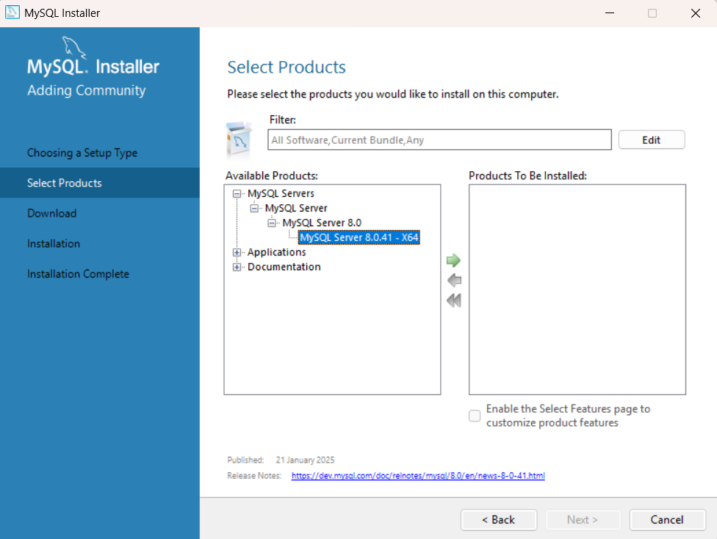



Click on the after selecting the Mysql Server

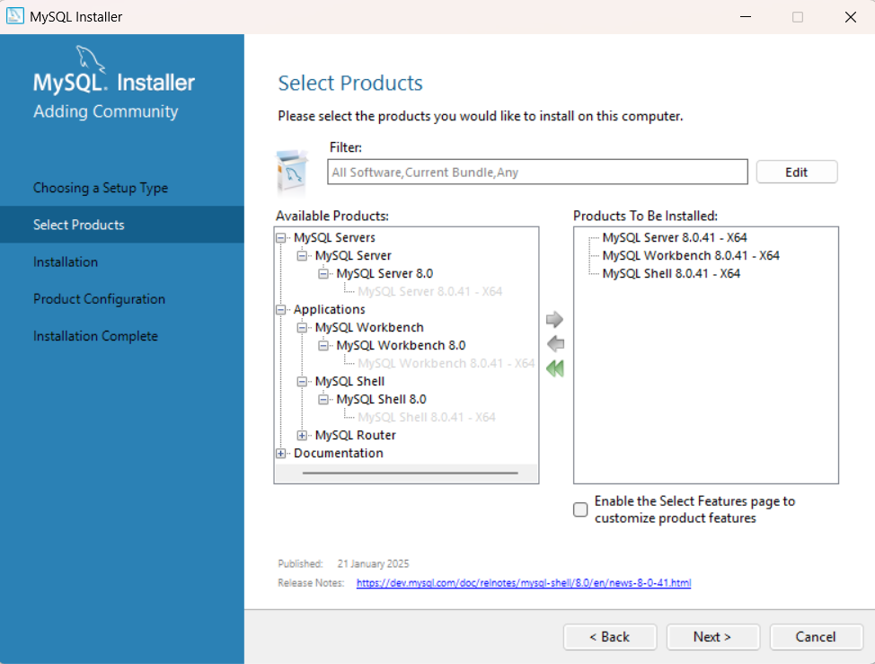

Follow same and add these there products and click on next

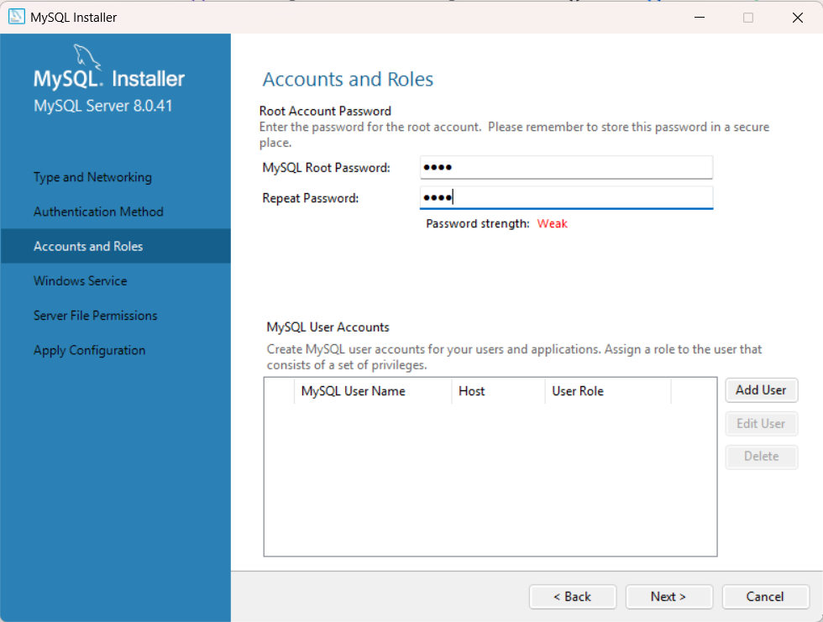

Keep the password as “root “so that you cannot forget

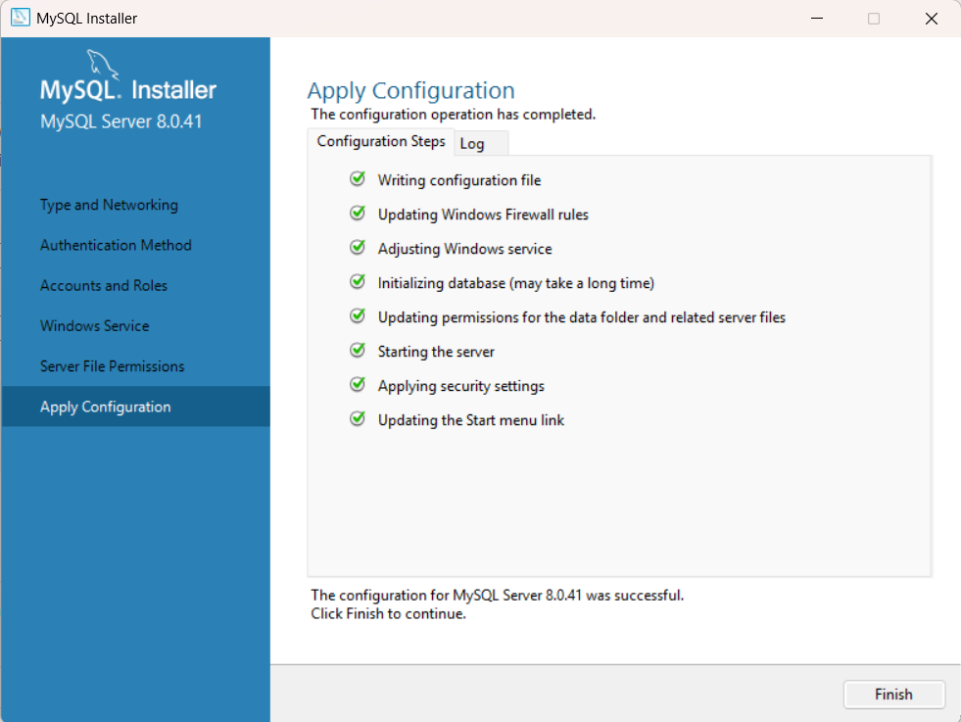

Click on Finish

To Add path to the Environment Variable

Goto the file path where mysql is stored

You can see on C drive or something

C:\Program Files\MySQL\MySQL Server 8.0\bin “These is for reference if your path iks same then you can use these”   
  
 . 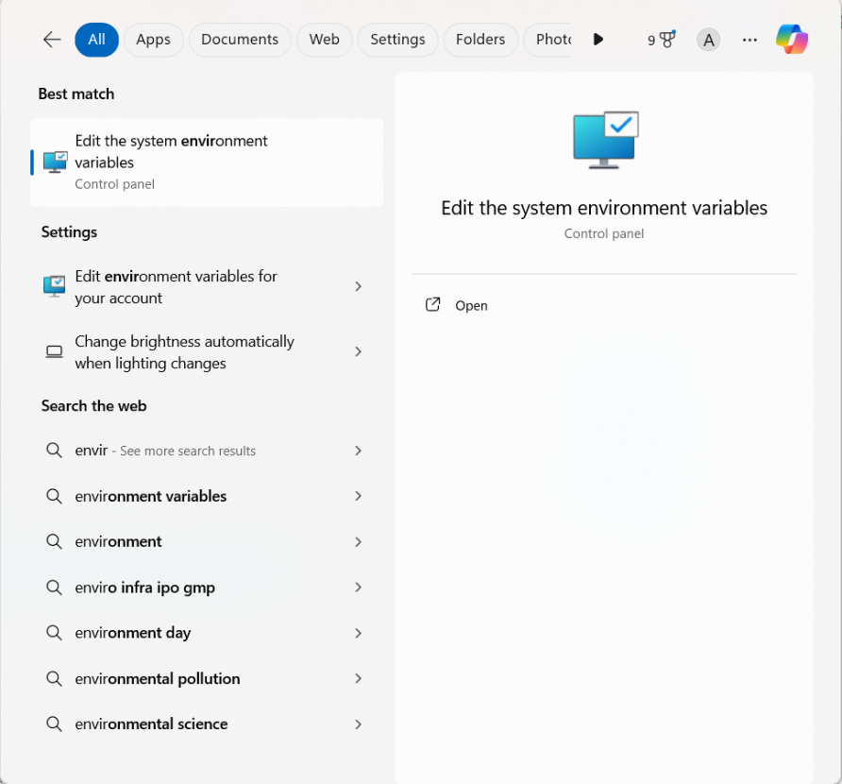

In Seach Bar

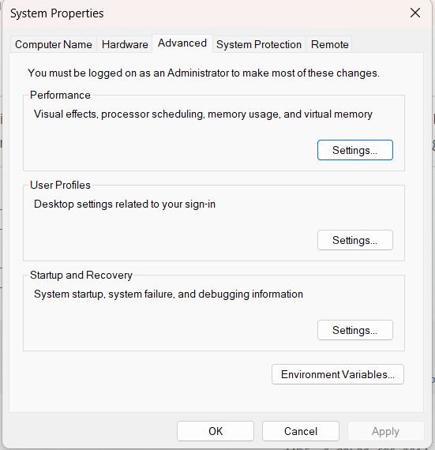



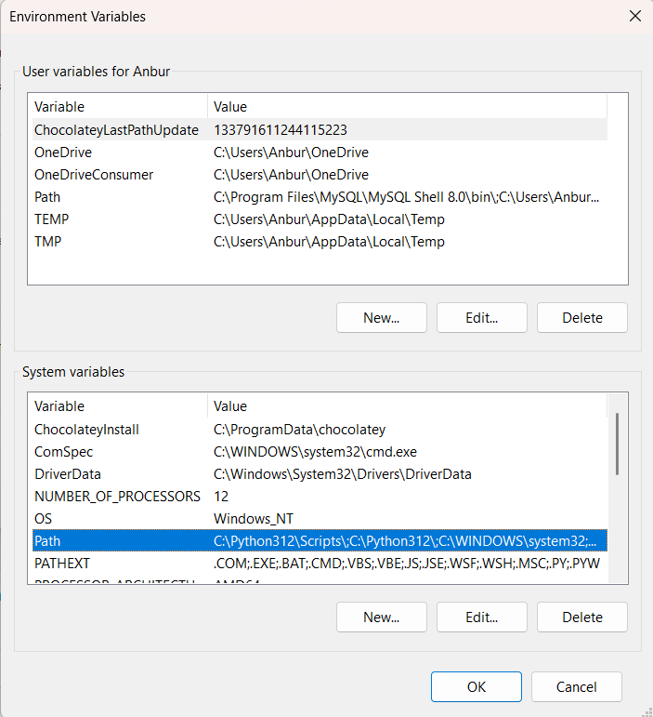  
Click on Edit

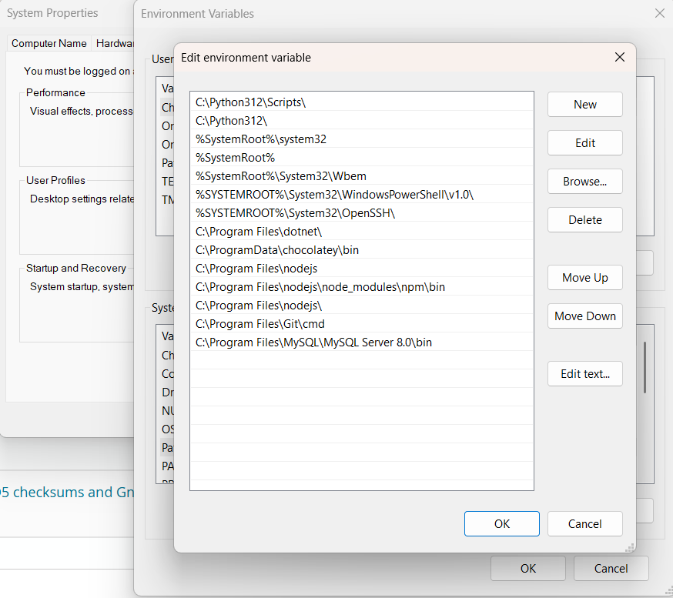

Add then then click on Ok on Every Dialog open